Dear future Year 6 students,
This is just a short letter to welcome you to your new class and to being top of the school! Whilst Year 6 has some obvious hurdles (yes, the dreaded SATs being one of those hurdles), it is also incredibly rewarding to those who are up for the challenge. It is not a year that should be feared – you will all achieve some wonderful things. I promise you that. Year 6 is a great opportunity for personal growth and academic improvement, both of which will be vital after so much time out of school. But we don’t need to worry too much about any of that yet…
There are, however, a couple of things to have a think about over the summer before we welcome you back:
- Would you like to put yourself forward for house captain? Those who are up for it will ‘pitch’ to their respective house in the first week back. There are many leaders amongst you so give it a go!
- What would you like the class rules to be? We are going to spray paint these onto the wall in the classroom, so make sure they are well thought out and appropriate!
Myself, Mrs Knight and Mrs McInery are very much looking forward to working with you all in your final year at SAVS. I have had many encouraging conversations with Mrs McInery, Mrs Kelly and Mrs Winterbottom about what you could all achieve. Before you know it, this will be you:
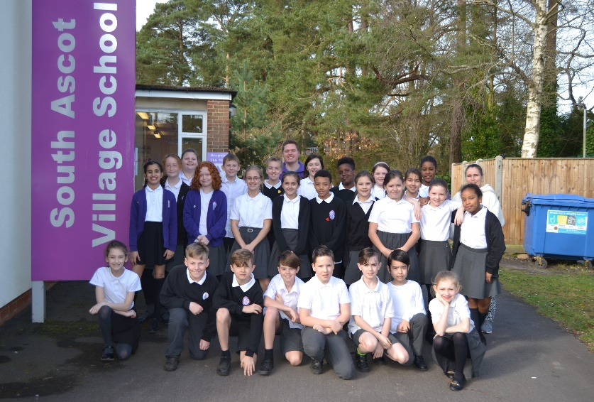
Enjoy your summer and I will see you in September,
Mr Forrest.

