Welcome to Year 4!
Hi Everybody!
I hope that you are all well? I’m really looking forward to seeing you all again in September. We were last together in Year 1, which seems like yesterday. I can’t quite believe you are now Year 4.
I am so looking forward to seeing how you have grown and what you have achieved. I am so excited about the year ahead of us and what I have got planned. We are going to have a lot of fun together, help each other and achieve new heights.
You’ll also be pleased to know that Mrs Hughes and Mrs Shepherd are coming with us on our journey!
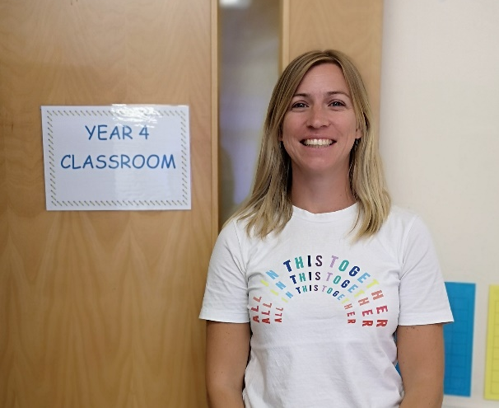
See you soon
Mrs Grumbt

