Welcome to...

My name is Miss Webb and I will be your Year 3 teacher. I have worked at South Ascot Village for 4 years. I love working in Year 3 because there are lots of interesting topics. During lockdown I have been reading, drawing and doing yoga. I’m enjoying spending more time with my family but have missed school.

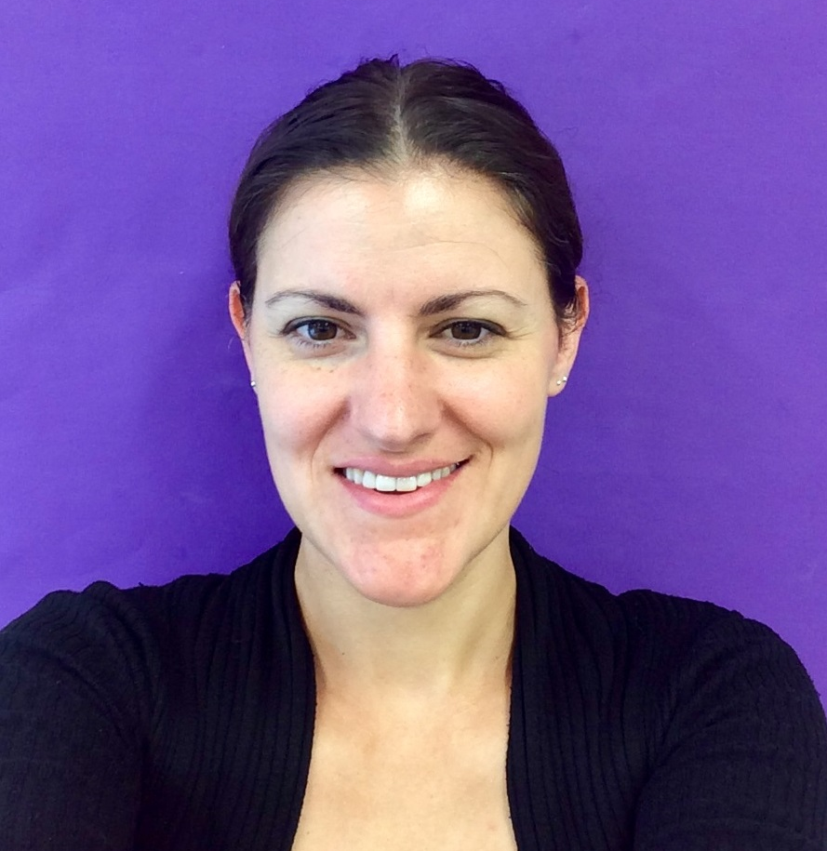

I have met many of you before in after school clubs or golden time groups. I have heard lots of wonderful things about you from Mrs Kelly and Mrs Grumbt and been admiring your Year 2 work.

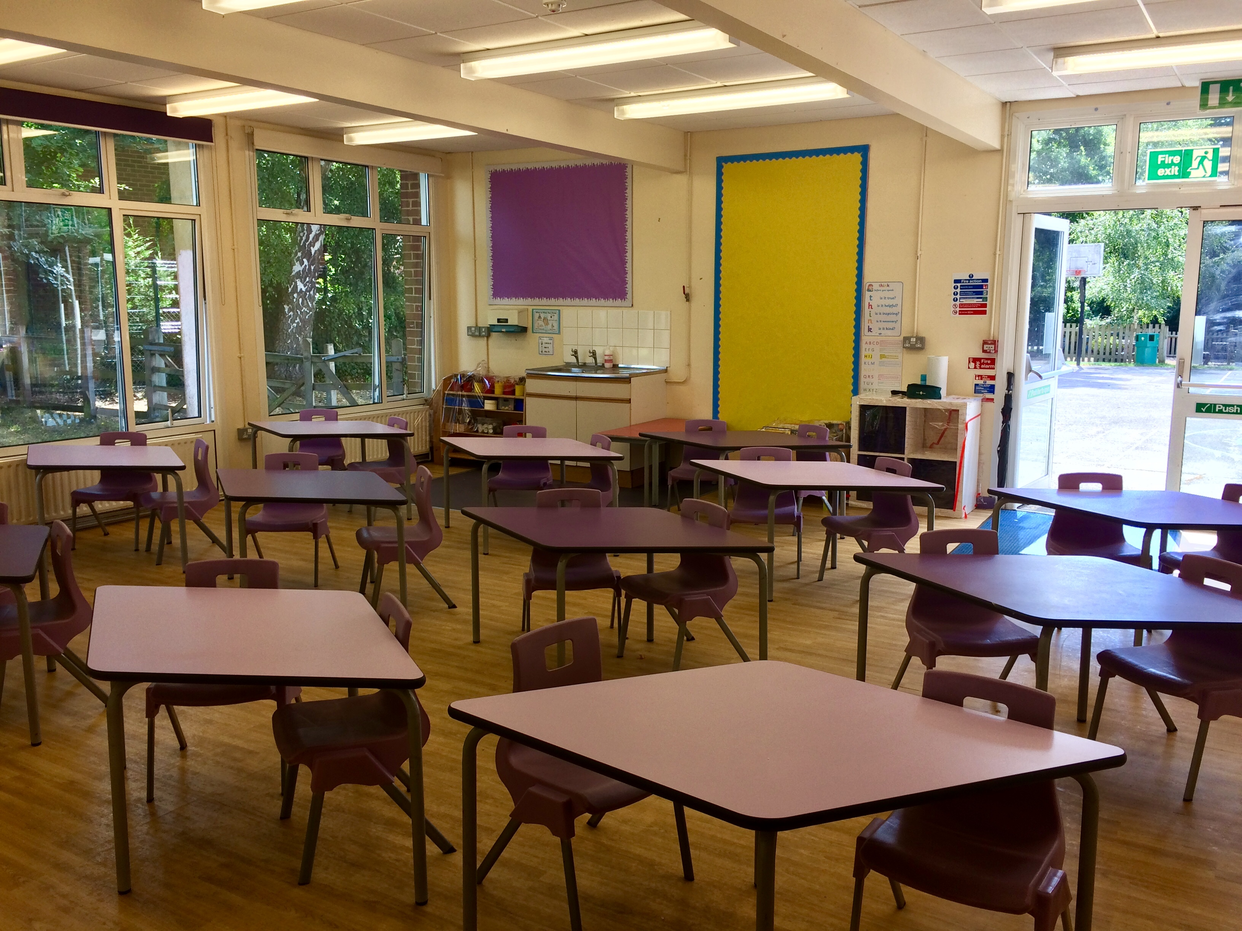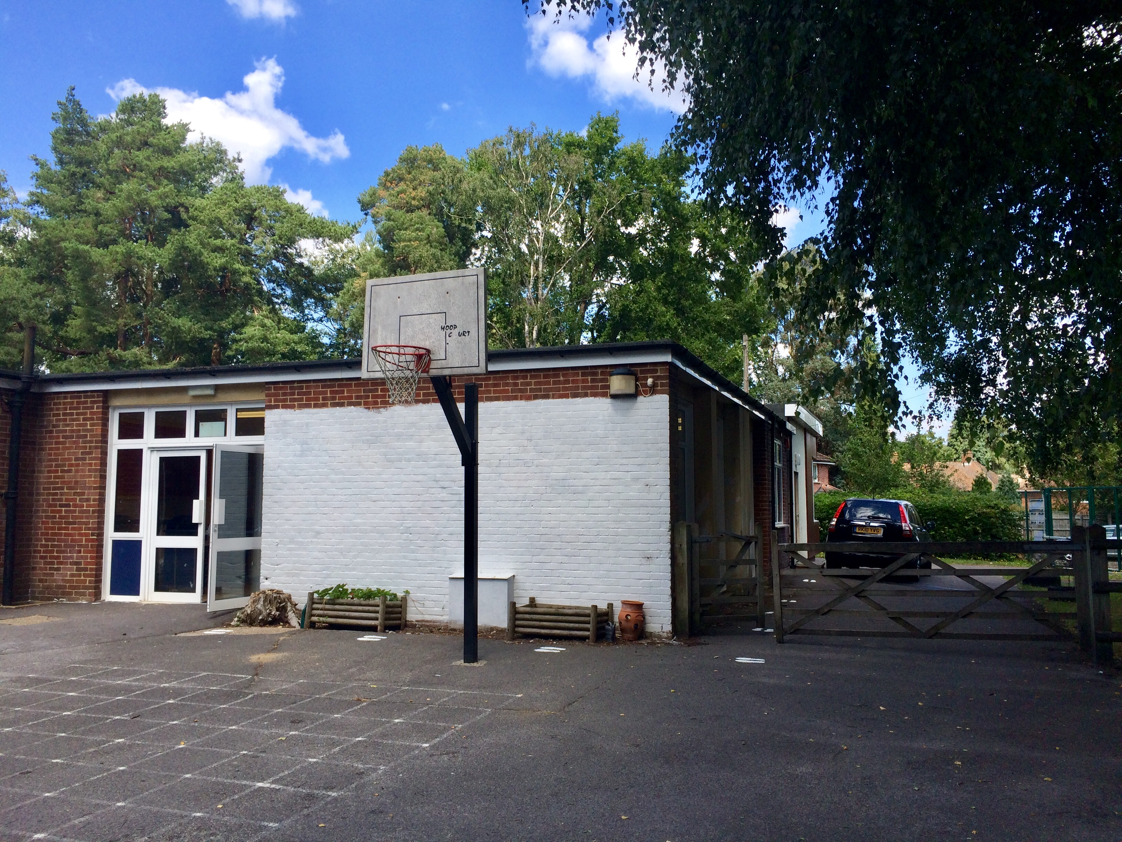

Our Teaching Assistant is Mrs Wynne
We look forward to welcoming you back and working with you in September
Have a wonderful holiday!

