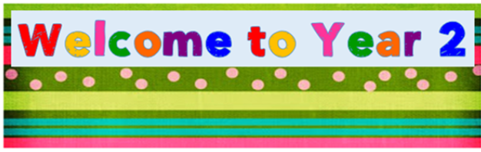
Dear children and parents,
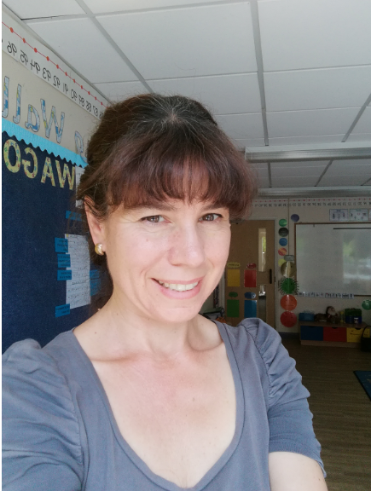
Let me introduce myself. I am Mrs Winterbottom and I will be teaching Year 2 from September. I look forward to welcoming you all!

Other adults working with us will be:
Mrs Kidd (Teaching Assistant); Mrs Abbott (Teaching Assistant and speech and language); Mrs Higgins (P.E. and Forest School Teacher) and Mrs Anderson (Teaching Assistance and Forest School Assistant).
I have already had the pleasure of seeing some of you (from afar!) in the last few weeks.
Have a great summer. Look forward to meeting you all.

Mrs Winterbottom

