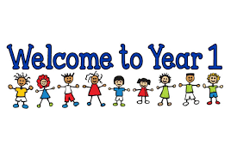

I just wanted to say how much I am looking forward to teaching you in September. Usually, by now, we would have had a morning together and got to know each other. However, we all have had a very different few months at home- having lots of time with our families and having a very different routine from normal.

I am looking forward to getting back into a school routine and enjoying teaching some lovely smiley faces again. We will start in September very gently and you will be doing things that you were familiar with when you were in F2. I promise you it will be fun and that you will have a happy time in Year 1.

When you see me at the beginning of term, I am sure a lot of you might recognise me from being in assembly and in the hall during lunchtime. I think I may be able to recognise a few of you! Take care over the summer and see you soon.

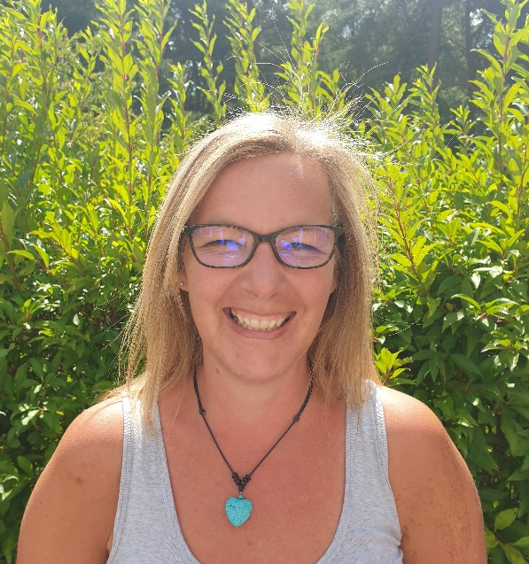
Best wishes
Mrs Kelly

