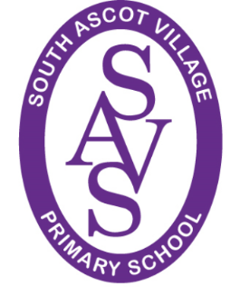
27th March 2020

Dear Parents

We are at the end of week one in the closure of South Ascot Village School due to the government’s necessary actions to combat the COVID-19 pandemic.

Thank you…
I would like to sincerely thank you all for keeping your children away, unless it has been absolutely essential. This collaborative action, by all of you, has meant I am able to significantly reduce the numbers of staff on site and reduce the risk of infection to you, your children, staff members and our wider school community. It is very much appreciated.

If you need us…
We are still available to help all of you if you require support, via email or phone. This will also include being open over the Easter holiday for critical worker’s children, if they need to attend school, together with those children who are deemed to be vulnerable at this difficult time. Please inform the school if you need to access this provision so staff and services can be arranged.

Home activities…
Work/activities for all pupils are being posted on-line for those who wish to access them. Please type in our school’s home address into the address bar directly or click on this link: www.southascotvillageschool.org.uk (We are having issues with the google search engine, but otherwise it should work). We will not be monitoring this work… Please feel free to ignore it, or be more creative with your children. Take this increased time to have quality communication and play with your children – learning will evolve naturally from these positive interactions. Looking after your mental health, and that of your children, is more important that completing written tasks – unless that is what ‘floats their boat’ and keeps them grounded!

Keep in touch…
If you have anything to share please send to main@southascotvillageschool.org.uk – it would great to see what is going on in our extended school. Mr Forrest has set up a specific email for year 6 to share their photos and activities - year6savs@gmail.com. For anyone who needs support from Mrs Kelly (SENCo) please use senco@southascotvillageschool.org.uk

And finally…
Although we are physically apart, we at SAVS are in the belief that:
‘Together we have strength’.
I hope you all continue to be in good health. Keep happy and safe…
Miss Kate Rimell

