Dear Parents/Carers

A big welcome back to school and more importantly a huge welcome to Year One. We really hope that you have had a restful summer holiday! We are looking forward to teaching your child this year. We thought we would just let you know a little bit about our routine
in Year One this year so you can keep up to speed!

- Your child will be expected to have a pair of outside shoes that are quick and easy to put on, that will also be doubled up as their PE shoes. No laces unless they are able to do them independently. They have the pleasure of playing on the field and in the woods. Allowing them to have a pair of outside shoes saves their smarter school shoes! These will stay in school every day.
- PLEASE ENSURE THAT EVERYTHING IS LABELLED
- Their PE days will be Monday and Thursday. They will need to come into school already changed for PE on those days.
- Wednesdays your child will have Forest School. There will be a separate letter for this.
- Every child needs to bring in a water bottle daily with water in it.
- Please ensure your child has a book bag rather than a large ruck sack that largely remains empty!

Your child should have received their reading book. We actively encourage your child to read daily for 10 minutes at least. Research shows that this is essential in order for your child to progress at a successful rate and to develop a real love of reading. There will be a book bag book linked to phonics and a book to share with your child. As the term continues, we will be sending home some key words for them to learn to read, but we will send a separate letter informing you about this nearer the time.
Every day we will be doing phonics with your child, and we will also be sending these home to reinforce their learning.

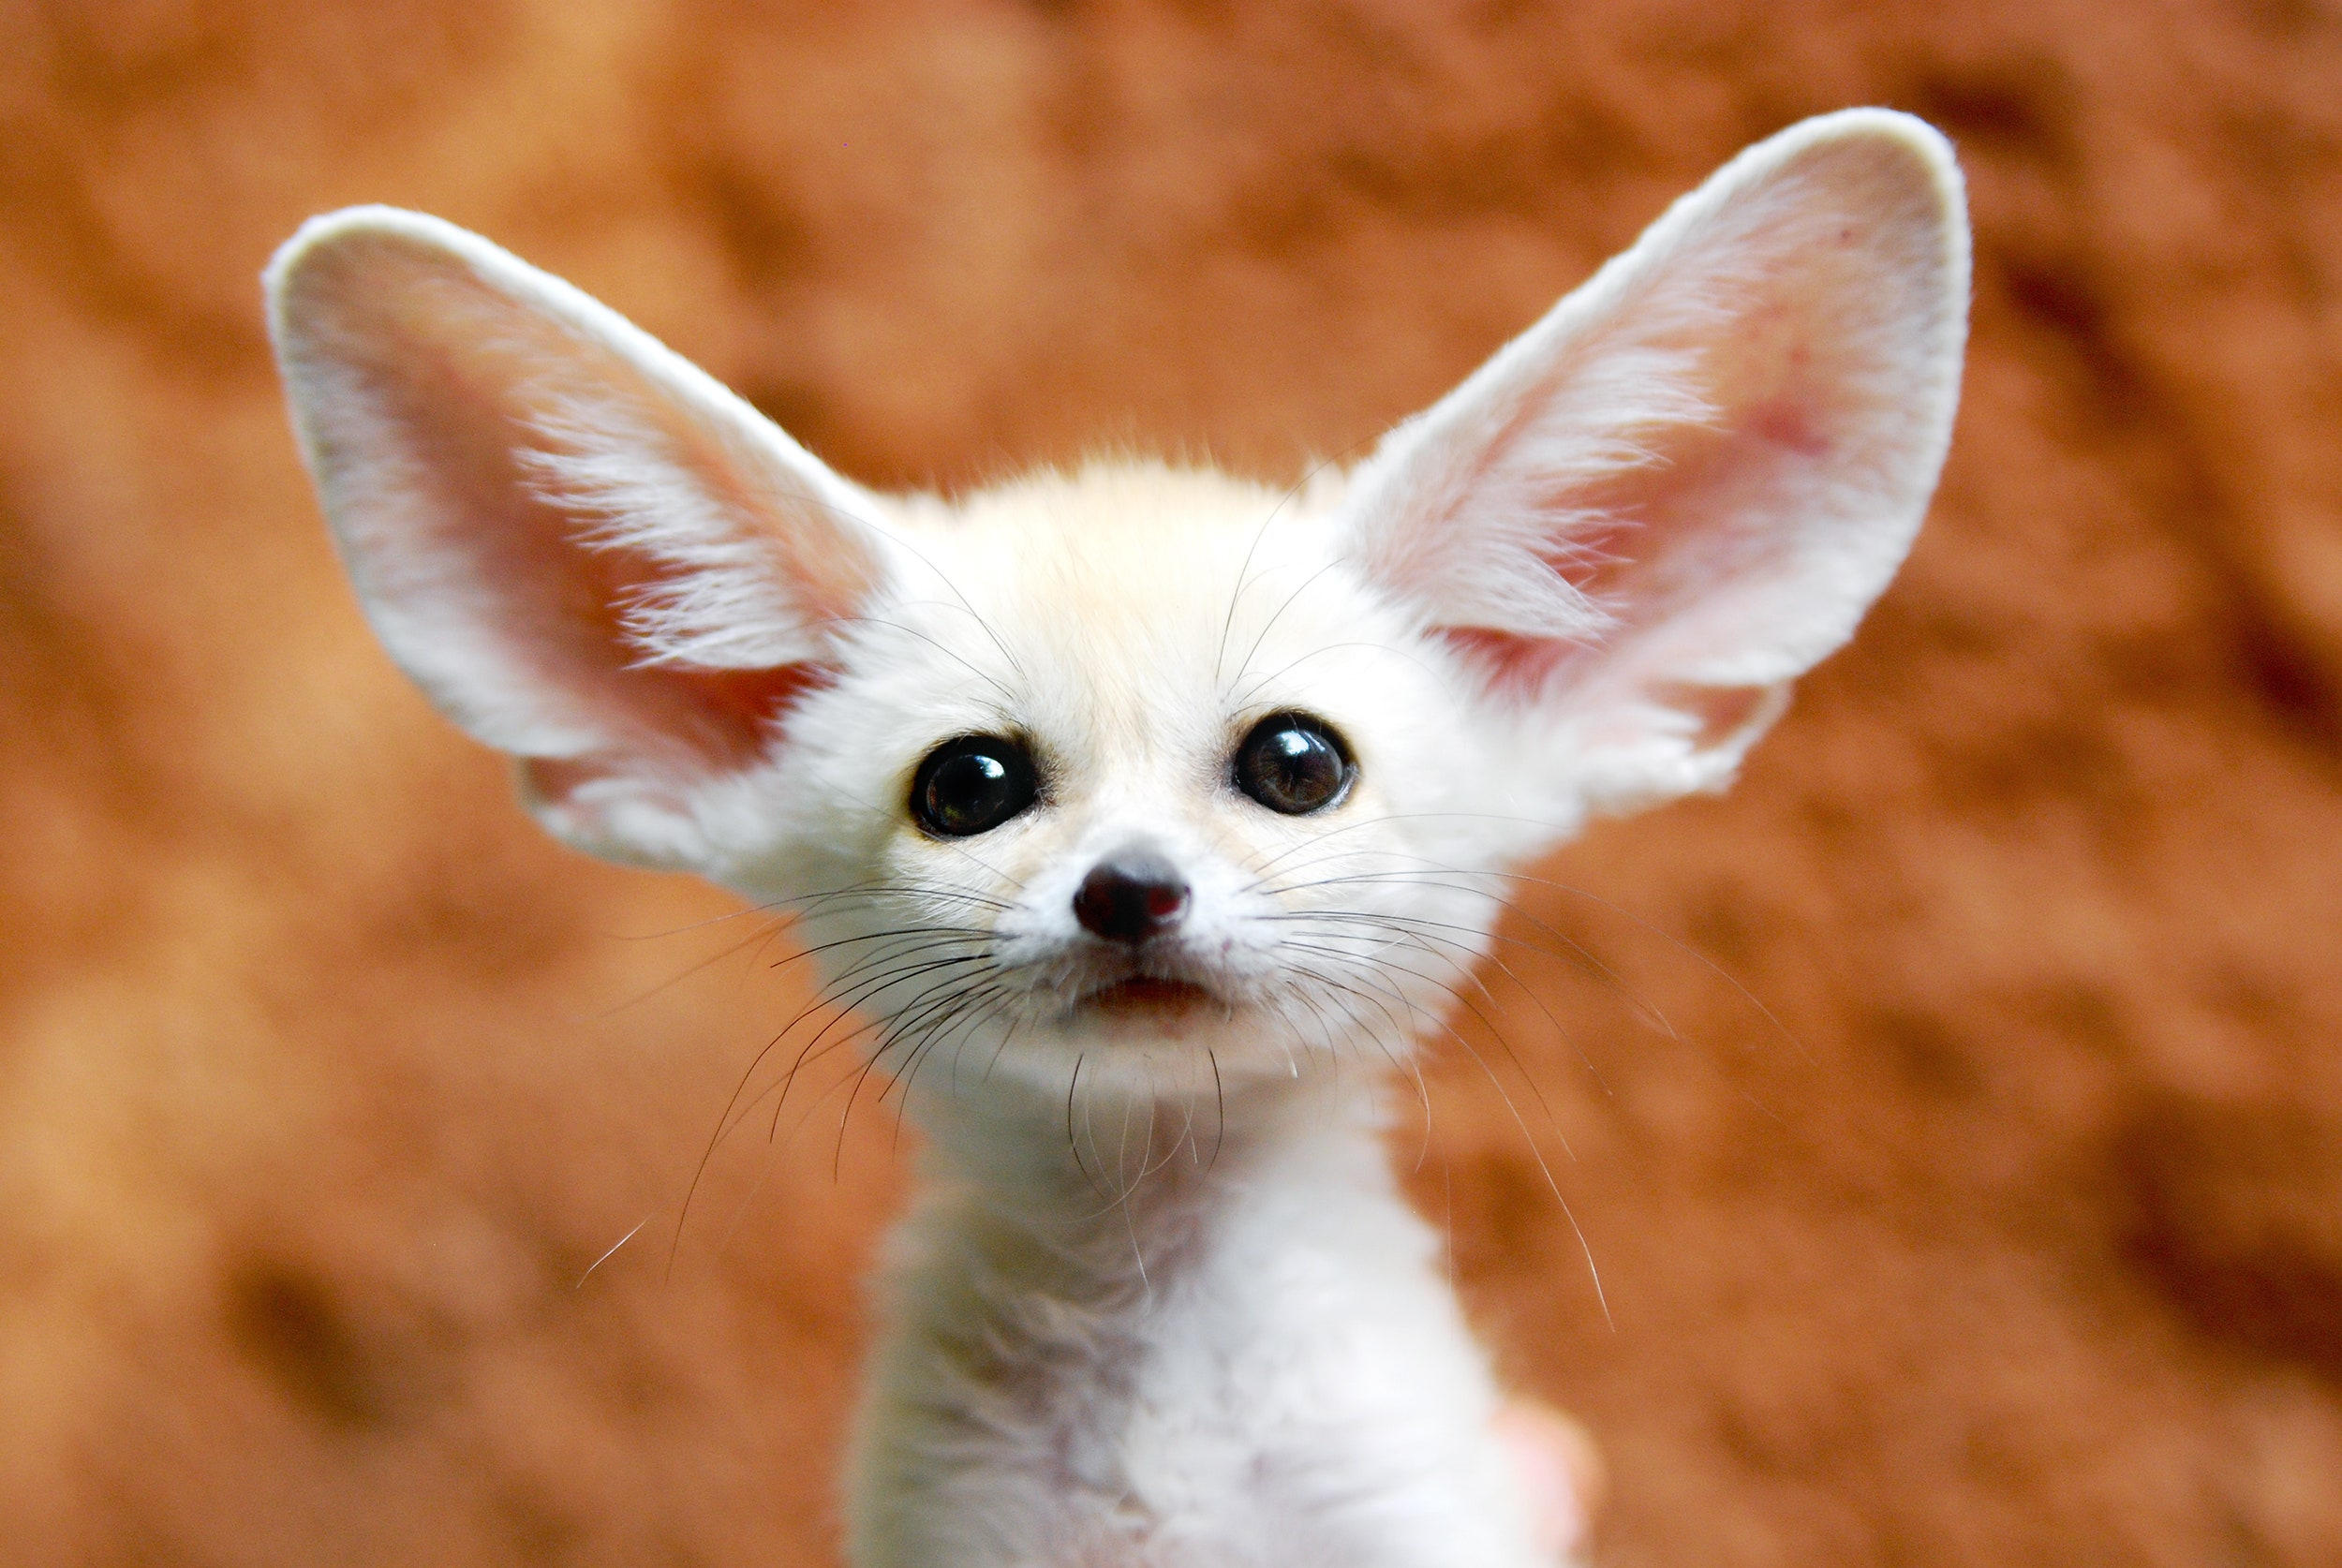
This term our topic is ANIMALS and HUMANS. We hope to kick start this topic in science by identifying and naming a variety of common animals including fish, amphibians, reptiles, birds and mammals. This will lead on to them identifying and naming a variety of common animals that are carnivores, herbivores and omnivores. They will also learn about the basic parts of the human body and say which part of the body is associated with each sense.

In History they will learn about their family and personal history and use photographs and artefacts to learn about the past. They will find out about local geography based on their home and school environments-making basic maps and using symbols as well as learning about the seasons and weather patterns.

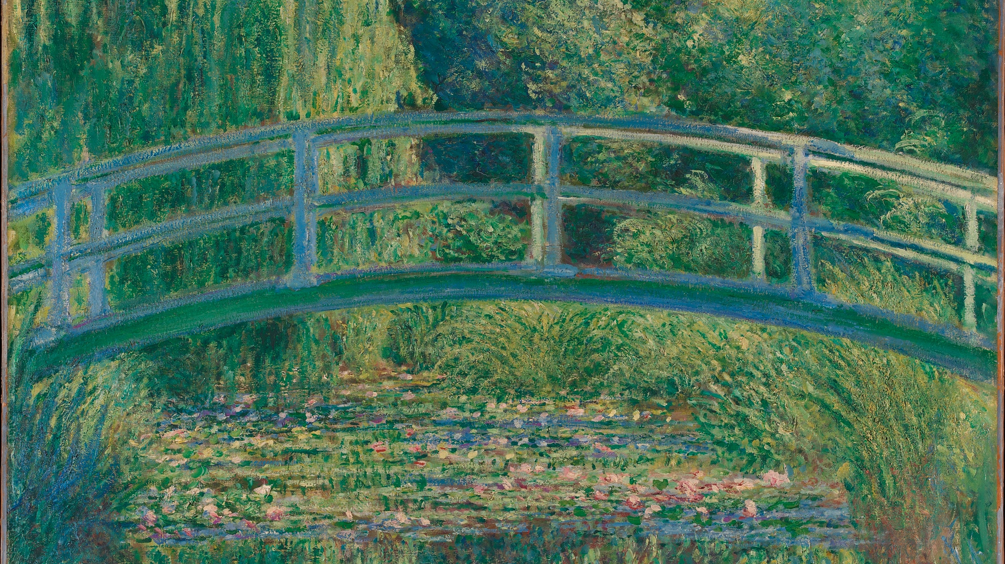
They will learn about Monet and perfect their drawing skills-using their observational skills! In addition they will draw their own self-portraits. They might teach me a thing or two here!

Music lessons will be related to the topic where they will learn to sing, talk about how music makes them feel as well as playing percussion instruments. Design and technology will involve using textiles to make an animal of their choice. They will learn about friendships and how to be a good friend as well as how to solve conflict situations. In PE they will partake in invasion games, net games and multi skills. RE will be learning about people belonging to different religious groups as well as learning about Harvest and Christmas.

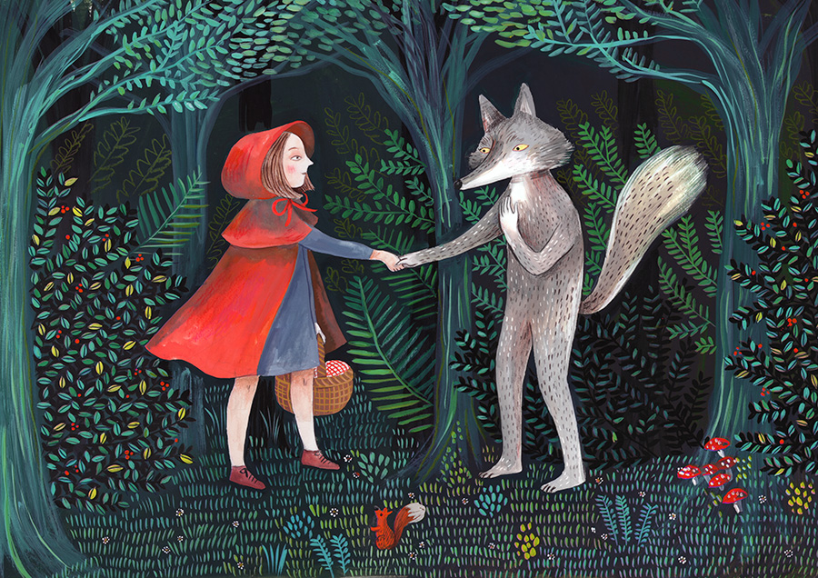
In Literacy we will look at traditional stories, non-fiction texts about animals and humans as well as animal poems We will write our own stories, information texts and poems. We will do phonics daily and group reading.

In maths we will be looking at number facts-addition/subtraction to 10 at least. More and less than a given number. Counting on and back from a given n umber as well as counting in 2’s, 5’s and 10’s. In addition to this we will look at 2D and 3D shape, length and weight.

I will keep you updated over the term with homework, reading, reading eggs etc -but will drip feed this gradually! In the meantime I would like to say that I am always happy to chat to you about your child and that I very much have an open-door policy. Obviously, sometimes are harder to chat than others, but please feel free to approach me when it’s appropriate and I endeavour to speak to you as soon as possible.

I look forward to meeting you all soon and embarking on your child’s learning journey this year.

Mrs Kelly

